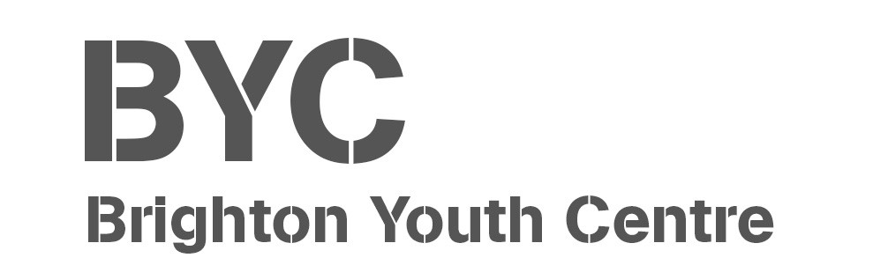

**BYC Events Team Staff**

BYC Events Team Staff

Job Title:

Brighton Youth Centre + other venues across the city

Location:

LIC/Project lead for B.fest (Lead Youth Worker)

Responsible to:

£11.50 per hour

Pay scale:

**Job summary:**

To be part of a dynamic and adaptable Events Team that support Young People, Events Managers and Youth Work team, to deliver successful, fun, creative, engaging and safe events for BYC.

To support the BYC team in inspiring young people to learn about themselves and others and build great lives by providing a dynamic Youth Centre that listens to Young People from across the city and works with them to provide space, training, activities, support, and services that are relevant and accessible and enable creativity, learning, fun, friendship and relaxation.

**Main Duties and Responsibilities:**

* Front of house: Greet visitors, check tickets, direct audience members, and provide information. They may also help with access requirements, collect lost property, and maintain the appearance of public areas.
* Stewarding: Help control crowds, direct attendees, and create a positive atmosphere.
* Venue management, ensuring the smooth operation of temporary or permanent venue spaces, supporting and allocating jobs to events volunteers.
* Event administration: Perform administrative duties, such as recording event data, assisting with planning, and communicating with guests.
* Stagehand and Technical support: Help with set-up, takedown, and deploying props and equipment. This could include, setting up gazebos, to supporting setting up PA or hanging artwork.
* Manage refreshments areas, and support event catering.
* Promoting: Engage with audiences by leafleting.

Monitoring and Evaluating

* + Contribute towards the recording of sessions through brief and debrief forms that all delivery is recorded and evaluated in line with procedures.

Other

* + To undertake training and attend supervision and staff meetings.
  + To adhere to all BYC policies and procedures
  + Promote equality and the valuing of diversity through all areas of work
  + To support a culture of learning and reflection
  + Any other duties which are in line with the grade and general level of responsibility of the post.

**Person Specification:**

|  |  |  |
| --- | --- | --- |
| **Qualification and Experience** | **Essential** | **Desirable** |
| Experience in running Events. |  | **x** |
| Customer service experience. | **x** |  |
| Experience of working with young people in youth work settings. |  | **x** |
| Experience in working with young people in any setting | **x** |  |
| Drivers Licence |  | **x** |
| **Knowledge and Skills** | **Essential** | **Desirable** |
| Excellent communication skills, with the ability to establish and maintain positive relationships with staff, volunteers, partner organisations and young people. | **x** |  |
| Good organisational skills | **x** |  |
| Understanding and experience of monitoring and evaluation in a youth work setting. |  | **x** |
| Politically and creatively aware with a good understanding of Youth Work principals. |  | **x** |
| Able to challenge, support and reflect appropriately and effectively. | **x** |  |
| Ability to prioritise effectively and enjoy multi-tasking in a busy environment | **x** |  |
| A clear understanding of the safeguarding young people and how to maintain appropriate professional boundaries in a Youth Work setting. | **x** |  |
| A good understanding of equality and diversity issues with the ability to challenge discriminatory behaviour. | **x** |  |