BRIGHTON YOUTH CENTRE – SESSIONAL YOUTH WORKER - BGAME

Role: Sessional Youth Worker

# Reports to: Leader in Charge (LIC)

Contract type: Variable

Location: Brighton Youth Centre, central Brighton (on site)

Hours: TBC

Practical requirements: Flexible hours including weekends and evenings

Pay Rate: £11.50 p/h

Job Purpose: Be part of a team to provide the Youth Work Programme for young people at BYC. This includes being part of planning activities, face to face delivery and safeguarding as required. You will take part in training, supervision and other meetings relating to your role.

We are looking for a creative, politically minded youth worker; someone who is willing to get stuck in and join our warm and enthusiastic team. Importantly, we are looking for someone who can demonstrate they are passionate about wanting to support and work with young people, and has a strong commitment to equalities and person centred practice.

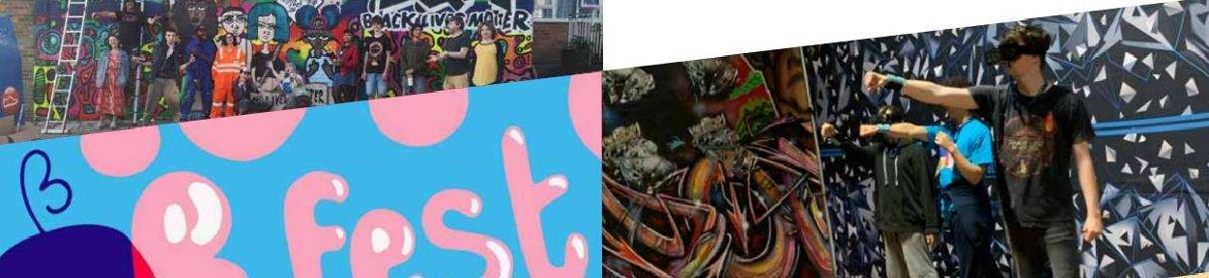

## ABOUT BRIGHTON YOUTH CENTRE (BYC)

Established in 1917, Brighton Youth Centre (BYC) is one of Brighton & Hove's longest running and best-used youth services. It's a thriving hub of activity, providing a central space for the city's youth work and attracting over 1 ,500 young people every year.

As a team, we're proud of the young people we work with and support, and we're continually impressed by the contributions they make to their local community through the activities at BYC every day. Projects such as B.fest, Brighton's biggest youth-led festival, facilities like Brighton's only indoor skateboard park, and the connections we offer to other services, including mental health, LGBTQI+ and refugee support, make BYC a very special and unique space in the heart of the city.

### Supporting Young People & Working in Partnership

BYC is a safe space where all young people have the freedom to be themselves, come together, learn from each other and challenge themselves to make a difference in their own lives and the lives of their community. We place their voices, aspirations and concerns at the heart of everything we do because we believe all children and young people deserve to be taken seriously. We work with over 20 partner organisations and projects who currently use the centre as their base, including specialist services for young people who are care experienced, on the autistic spectrum, LGBTQI+, asylum seekers, experience mental ill health or homelessness, such as Brighton & Hove Pupil Referral Unit, Allsorts Youth Project, YMCA DownsLink and Mascot; and youth arts and creative industries organisations like

Southeast Dance, BlockBuilders, Miss Represented and Art In Mind.

## JOB DESCRIPTION – SESSIONAL YOUTH WORKER BGAME

Sessional Youth Worker BGame

Job Title

Brighton Youth Centre

Location:

Leader in Charge (Lead Youth Worker)

Responsible to:

£11.50 per hour

Pay scale:

**Job summary:**

To be part of a team that inspire young people to learn about themselves and others and build great lives by providing a dynamic Youth Centre that listens to Young People from across the City and works with them to provide space, training, activities, support, and services that are relevant and accessible and enable creativity, learning, fun, friendship and relaxation.

**Main Duties and Responsibilities:**

Youth Work Delivery

* + Provide young people with personal and social development opportunities in a fun, dynamic and supportive environment through the BYC programme .
  + To work with young people in a way that respects and empowers young people, in line with the key values of youth work.
  + To work as a part of a team to support young people to:
    - Identify their needs and interests and facilitate learning and development through youth work
    - Plan and implement activities and projects
    - Become self-aware, gain confidence, and participate in society
    - Gain access to information, support and signpost where necessary
    - Promote their rights and responsibilities
    - Safeguard their health and welfare
    - Promote equality and the valuing of diversity

Monitoring and Evaluating

* + Contribute towards the recording of sessions through brief and debrief forms that all delivery is recorded and evaluated in line with procedures.
  + To contribute to yearly planning of activities and youth work programme

Other

* + To undertake training and attend supervision and staff meetings.
  + To adhere to all BYC policies and procedures
  + Promote equality and the valuing of diversity through all areas of work
  + To support a culture of learning and reflection
  + Any other duties which are in line with the grade and general level of responsibility of the post.

**Person Specification:**

|  |  |  |
| --- | --- | --- |
| **Qualification and Experience** | **Essential** | **Desirable** |
| Level 2 JNC qualified or relevant youth work qualification and experience. |  | **x** |
| Experience of working with young people in youth work settings. | **x** |  |
| Experience of developing youth work programmes |  | **x** |
| Experience in working with young people in any setting | **x** |  |
|  |  |  |
| **Knowledge and Skills** | **Essential** | **Desirable** |
| Excellent communication skills, with the ability to establish and maintain positive relationships with staff, volunteers, partner organisations and young people. | **x** |  |
| Good organisational skills | **x** |  |
| Understanding and experience of monitoring and evaluation in a youth work setting. |  | **x** |
| Politically and creatively aware with a good understanding of Youth Work principals. |  | **x** |
| Able to challenge, support and reflect appropriately and effectively. | **x** |  |
| Ability to prioritise effectively and enjoy multi-tasking in a busy environment | **x** |  |
| A clear understanding of the safeguarding young people and how to maintain appropriate professional boundaries in a Youth Work setting. | **x** |  |
| A good understanding of equality and diversity issues with the ability to challenge discriminatory behaviour. | **x** |  |

**Additional to role in BGame:**

|  |  |  |
| --- | --- | --- |
| **Qualification and Experience** | **Essential** | **Desirable** |
| Experience or training understanding Neurodiversity and/or Mental Health. |  | **x** |
| Experience of working in gaming environments |  | **x** |
|  |  |  |
| **Knowledge and Skills** | **Essential** | **Desirable** |
| Has an interest in Role Playing Games (RPG) like Dungeons and Dragons 5e or other RPG games. |  | **x** |
| Has adequate knowledge in digital and/or tabletop games. | **x** |  |
| Have experience working with 3D printing, and game design. |  | **x** |
| Creative thinking and Problem solving skills |  | **x** |

Your duties will be as set out in the above, but please note that BYC reserves the right to update your job description occasionally to reflect changes in or to your job. You will be consulted about any proposed changes.

HOW TO APPLY:

Please complete the application form and send it to: office@brightonyouthcentre.org.uk

|  |  |
| --- | --- |
| Closing date & time | The application deadline is 9 am on: 8th November 2024 |
| Interviews | Interviews will be held on: Within two weeks of application deadline.  The interviews will take approximately 1.5 – 2 hours.  Please let us know when you submit your application if you have any issues with the interview date and time. |
| Additional information | If you are experiencing any barriers to attending the interview or applying for this role, please do get in touch. Brighton Youth Centre will try and meet any additional needs within its capacity and resource to do so. |
| Contact | You should find the necessary information in this pack and on our website @ [Brighton Youth Centre](https://www.brightonyouthcentre.org.uk/), where you will discover more about who we are and what we do. However, if you want an informal discussion before applying, please call the office on 01273 681368 and we would be happy to chat further about the role. We look forward to receiving your application. |